Library Name: | cgm
Cell Name: | DFFX1
Function/Truth Table:
CLK D Q |  | Comment
↑ (rising) 0 0 |  | Q follows D on rising edge
↑ (rising) 1 1
  Q follows D on rising edge
0 or 1 (not ↑) X Q(No Change ) |  | No rising edge → Q holds its value
Set Up Time D=1
Pre-layout |  | 70 ps
Post-layout |  | 100 ps
Hold Time D=1 (if not negative)
Pre-layout |  | -50 ps
Post-layout |  | -70 ps
Clock to Q-Delay
Pre-layout |  | 1.70397ns
Post-layout |  | 1.73977ns
Layout Height: 1.71nm
Layout Width: 8.4nm
Layout Area: 14.364 nm²
Symbol with Port Names:
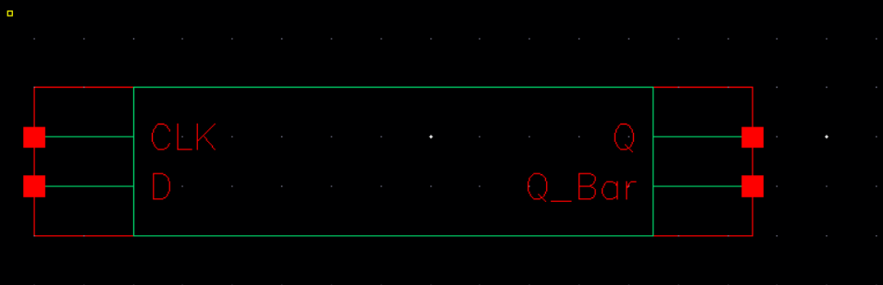
Schematic:
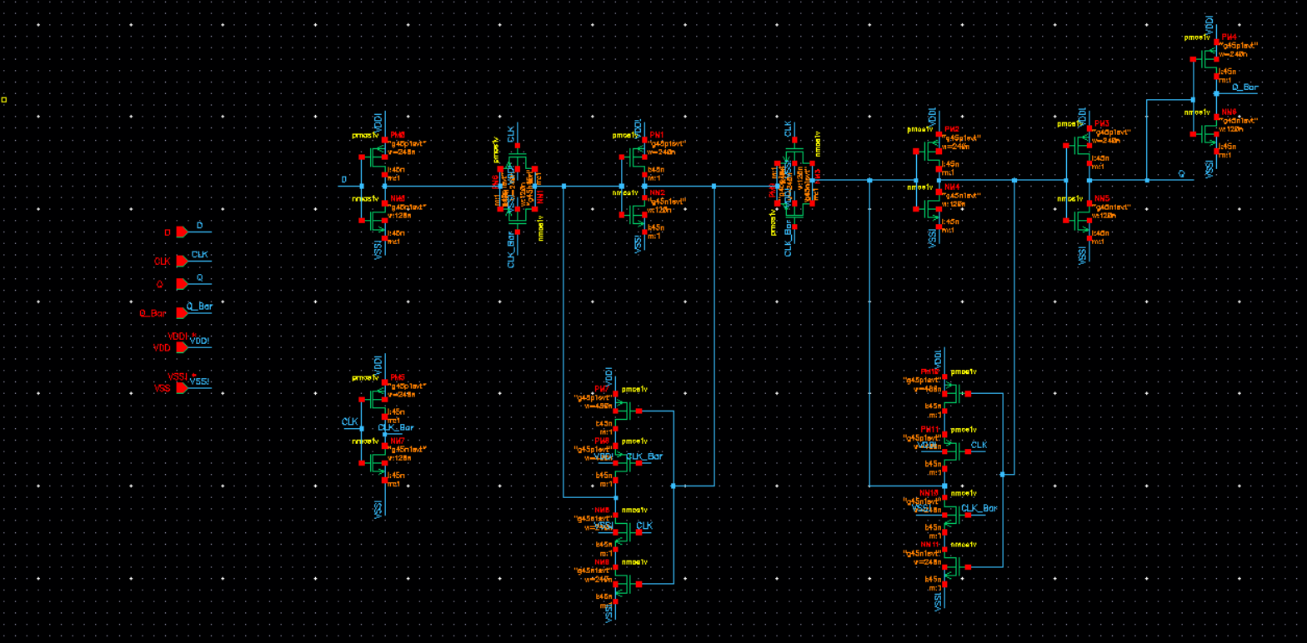
Layout:

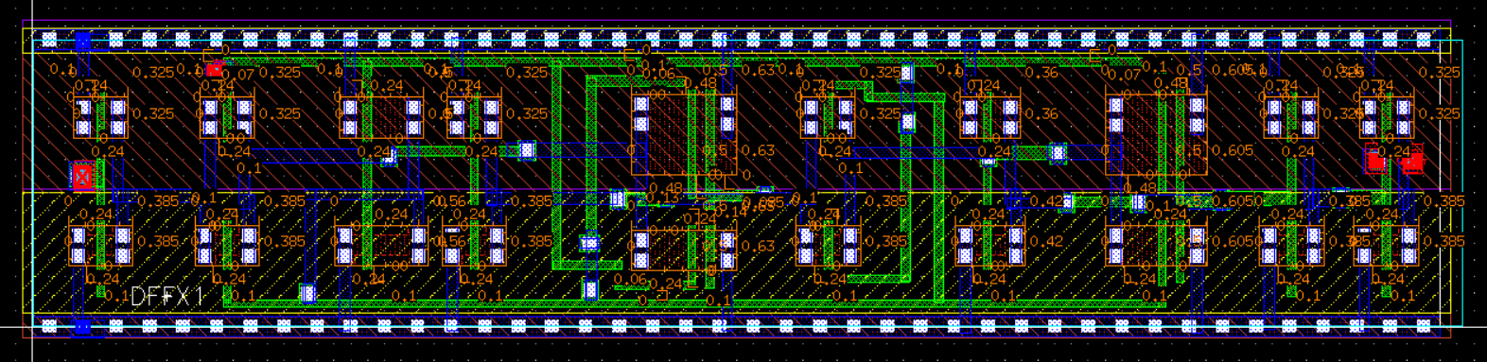
Functional Simulation Waveforms
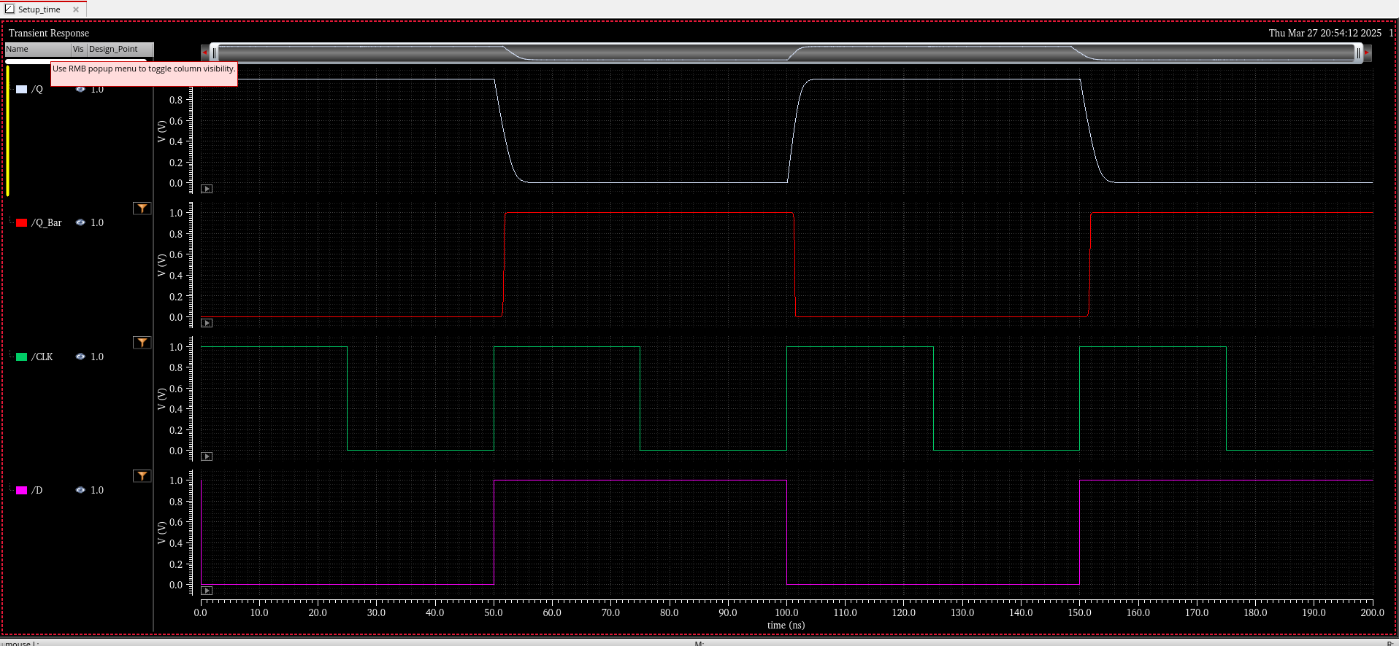
Comments/Notes:
In both pre-layout and post-layout simulations, the flip-flop exhibits negative hold time behavior. During pre-layout simulation, failure was observed when D changed between 49.930 ns and 49.950 ns, but Q correctly latched the data when D changed at 49.960 ns, resulting in a hold time of –50 ps. Similarly, in the post-layout simulation, failure occurred when D changed between 49.900 ns and 49.930 ns, but worked correctly at 49.890 ns, confirming a hold time of –70 ps.

This behavior indicates that the flip-flop can reliably latch data even when the input D changes slightly before the rising edge of the clock. This is due to internal delays where the data path is slower than the clock control path, creating a small timing margin that allows early transitions on D without corrupting the output. In essence, negative hold time means the flip-flop is tolerant to slight timing violations immediately after setup, and can capture data reliably even when D changes just before the clock.

